King George Chapter of the American Wine Society 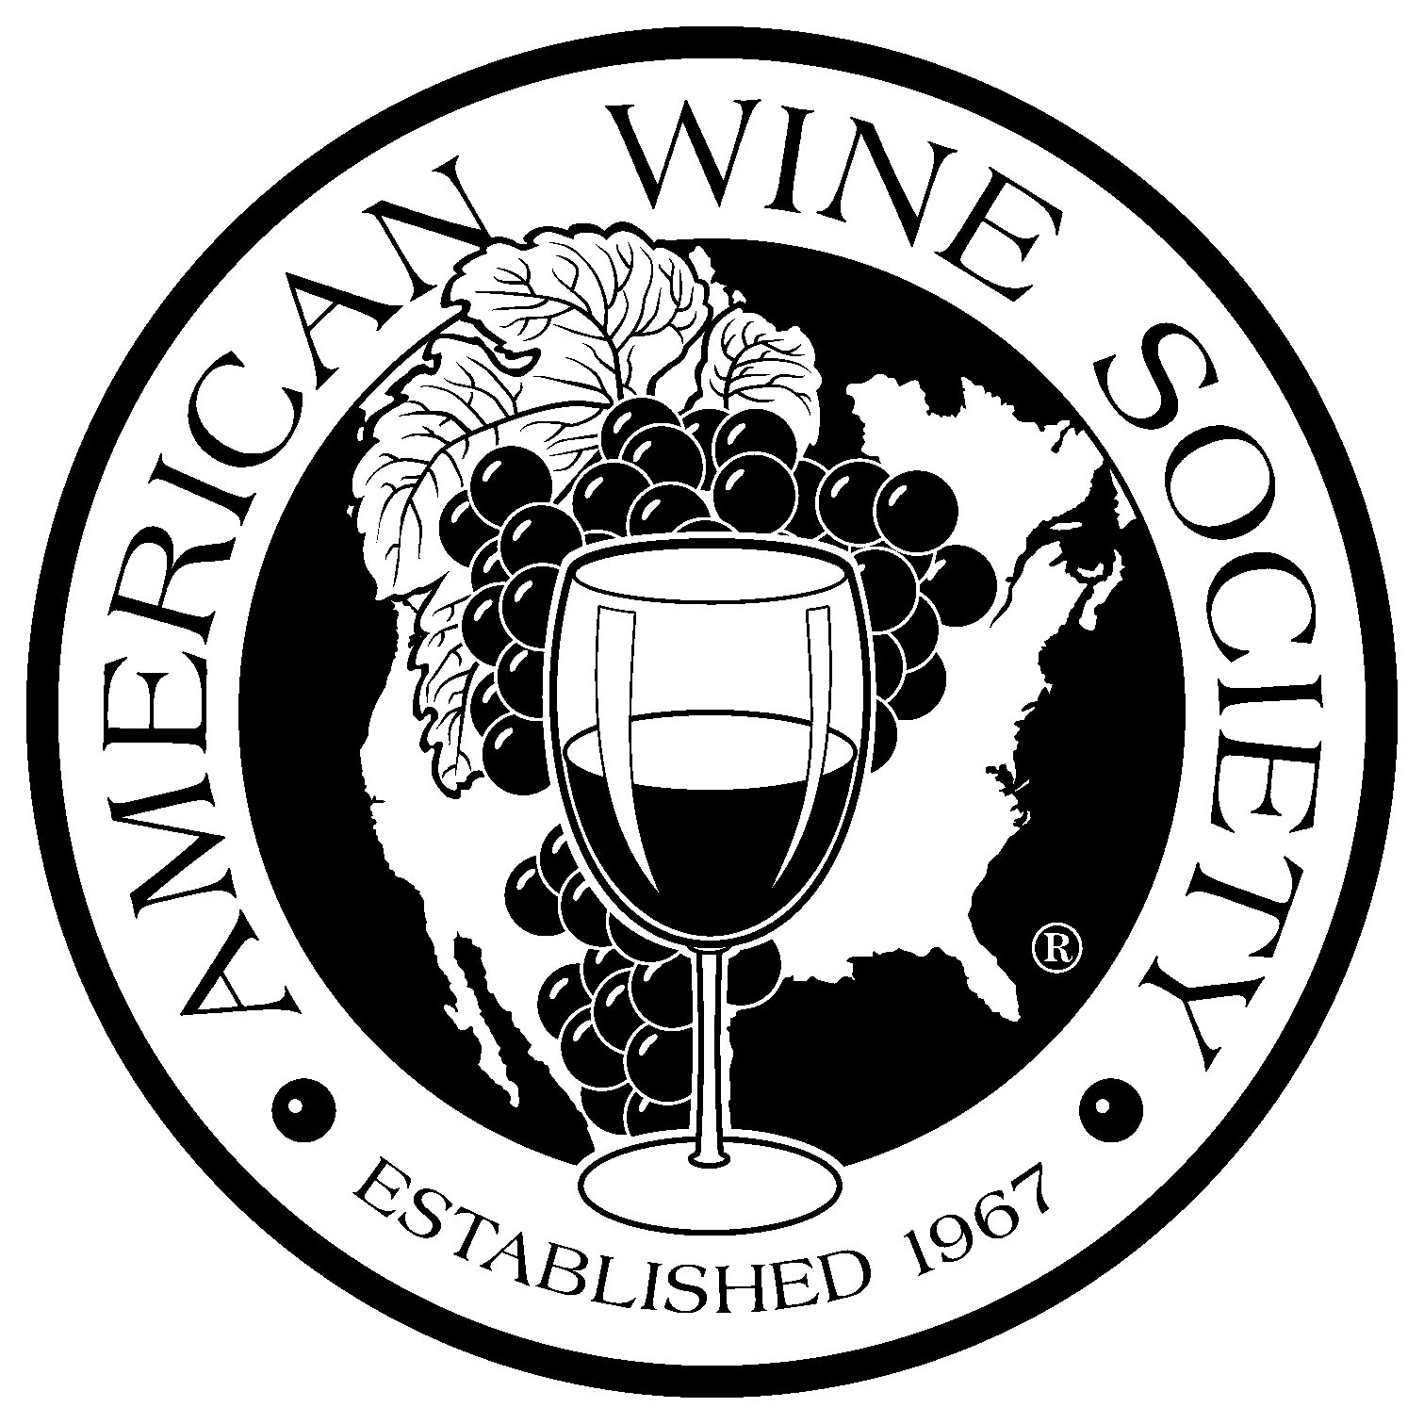
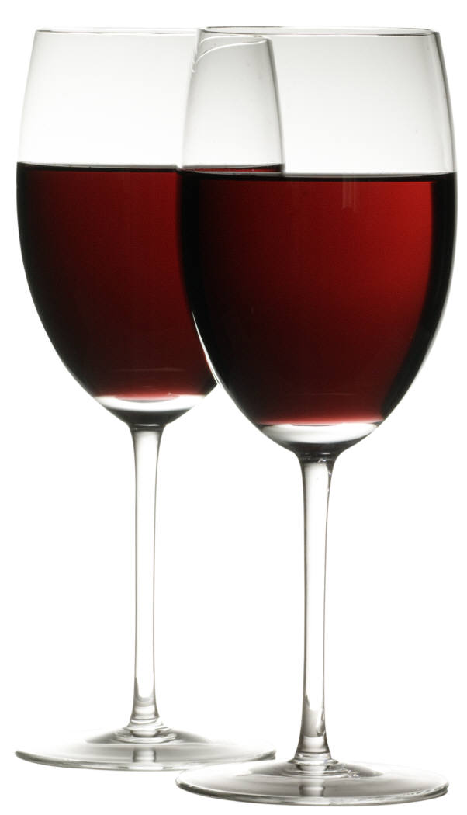
July 8, 2011

General Discussion:
Old News:
- New/Updated Tasting Fee: The Treasurer began collecting a Tasting fee from members of $12.50 and the Guest Fee will return to $15.
- ‘Library’ or ‘Special’ tasting meetings where the dues would either be raised or based on attendance should go up for Society/Board approval at least 30 days in advance – Motion voted and carried.
New news:
- Next month’s Tasting and presentation – Next meeting will be a Special Library Tasting
  - Motion proposed to raise fee for this special tasting to $15.Motion carried (This is within the 30-Day approval of Board).
  - Request for RSVP via the web site, or e-mail to Terri at least two weeks prior to the next meeting (August 12th).
- If you have not yet paid your National Dues, please do so ASAP!

Presentation:
“Wines of the Finger Lakes Region, New York State” – Lonni Wersal, Ci Niznik

Lonni and Ci had a lovely plan to take a tour of the Finger Lakes region of New York and do wine tastings along the way…the plan included bringing back a sample of their findings to share with the group for this presentation. Well, like many of us with grand vacation plans that get pushed aside by life…sadly their plan never came to fruition. Because of that, Lonni and Ci had to deviate from the ‘plan’ a bit and instead of taking a tour of New York, had to take a tour of the Wegmans New York State Wine Aisle as well as search the regions of Total Wine for the wine they brought to share with us.
The wines they chose were from several different regions of the Finger Lakes. Our wine tasting tour of these regions included:
- #1 - White Cat (no vintage), Niagara is the primary grape.
Hazlitt 1852 Vineyards Seneca Lake Easter Shore, 5.3% residual sugar, 11.2% alc
The primary grape in this white blend is Niagara which is also used to make white grape juice. This wine was fermented all in stainless. It was a nice refreshing, very smooth wine; would be a great summer wine. Makes you want to go lay in a hammock with a cold glass!

- #2 - ’07 , Dry Reisling
Konstantin D. Frank & Sons Vinifera Wine Cellars, LTD, Keuka Lake .6 % residual sugar/12% alc.
Dr. Konstantin has been doing wine for a long time. He is known for “The father of Vinifera” in the Eastern US for pioneering viticulture methods that other wineries along the east coast are using with European varietals.
For this wine the fruit was harvested by hand during the cool hours and cold pressed. The juice was cold settled and fermented with select German yeasts. The fermentation was stopped just prior to dryness for balance. This was a pleasant Dry Riesling with a very characteristic palate.
- #3 – Tony’s Blush (no vintage) blend of Cayuga White and Rougeon (red hybrid)
Anthony Road Wine, Seneca Lake 5.4% residual sugar/10% alc.
This semi-sweet blend was done with primarily Cayuga White a small amount of Rougeon, which is a red hybrid, for the color and the remainder of the wine is a blend of several other white varietals.
- #4 – ’06 Pinot Noir
Fox Run Vineyards, Seneca Lake 12% alc.
Fox Run is located on the western slopes of Seneca Lake. The fruit was grown in low yields to ensure optimally ripe grapes. This is a medium bodied red with light oak.
Most of the comments across the room were that this did not show typical for a Pinot.
- #5 - ’07 Salmon Run Meritage Bordeaux blend of 54% Cab Sauv, 39.5% Cab Franc, and 6.5% Merlot
Konstantin Dl Frank & Sons, Keuka Lake 11.8% alc.
This is a classic blend of Bordeaux varietals. Barrel aged in mostly French oak for a year. This was a very big wine with lots of character.
- #6 – Fox Trot Red – Blend of Cab Franc and Concord Grapes
Fox Run Vineyards, Seneca Lake 3% residual sugar/12% alc.
This is a semi-sweet red table wine. Since it is a blend with concord grapes and has some residual sugar, you could chill this red. It was reminiscent of Welch’s grape juice. Would be great with peanut butter crackers!

Favorites and prices of the presentation:
Wine # | Votes | Price | Purchase Price:
#1 | 11 | $9.99 | Total Wine
#2 | 11 | $17.99 | Wegmans
#3 (voted as a white(W) and red (R) | W/3 R/7 | $9.99 | Wegmans
#4 | 3 | $17.99 | Wegmans
#5 (favorite overall) | 14 | $13.99 | Wegmans
#6 | 4 | $10.99 | Wegmans

The next meeting will be a Special Library Tasting: Wines and Olive Oil’s from Italy.
Please make sure and RSVP at least TWO WEEKS prior to the meeting if at all possible.
Meeting Date: August 12th
RSVP by date: July 29th.

There have been several changes to the web site since development. You should be able to utilize the RSVP tool now. Please send me any issues or comments regarding the web site. If you cannot use the web site to RSVP, please send an e-mail to Terri at terri@ourcayoloco.com

Thank you! See next month!

Cheers!

http://www.kgwinesociety.com/

